**Student Name: Weight: Contributes to 10% Engagement Mark**

**Student ID:** **Marks:** **Pass/Fail/Award**

# Group Exercise: SQL Simple SELECT

## Equipment and Materials

For this lab, you will need:

* A Windows computer with a minimum of 16GB RAM and 250GB of free disk space, capable of nested virtualization
* Access to ORACLE SQL*PLUS
* The following data provided in the course resources section of Brightspace:
  + JustLeeDatabase.zip
  + Labskeleton.sql

## Instructions

1. First, work through steps 2-5 individually. Then arrange a time to come together with your small group. As a group, create one solution based on the best individual solutions for each problem. Further refine the solution as a group as needed.
2. Review the physical model and data files provided on Brightspace.
3. Review the Problem Set, Tips for Success, and Marking Criteria sections of this document.
4. Write a single script that answers all the questions in the problem set.
5. Use the skeleton script provided as a starting point.
6. Only one submission is required per group. The submission should include:
   1. A single script file
   2. A spool file showing all results
   3. An attribution list that outlines the activities, time spent and resources associated with completing this assignment. attribution list is provided on Brightspace.

## Problem Set

1. Display the names of all the authors. The output should resemble the following list.

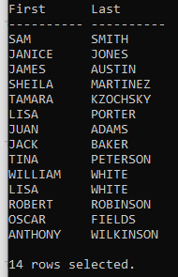

1. Display all order information. Include the order#, item#, ISBN, quantity ordered, book price, line total, GST (5%) and total price in the following format.

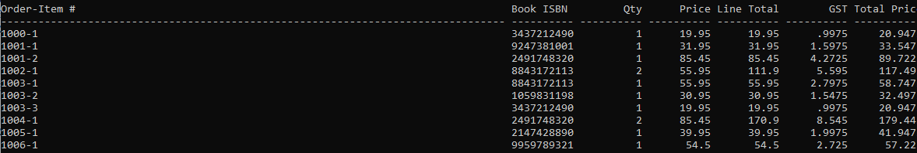

**Note:** The output above has been truncated to save space; 32 rows should be displayed.

1. Create a list of all AuthorIDs from authors that have written books. Remove all duplicates from the list.

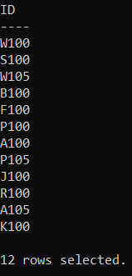

1. Show all orders and the number of days that it took to ship the order.

**Hint:** You can subtract dates.

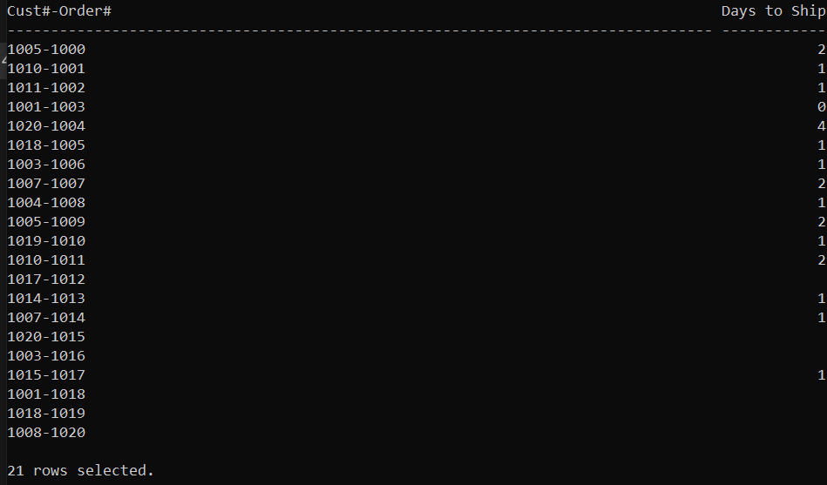

1. Show all customer information, including last name, first name, mailing address, and order number, in the following format:

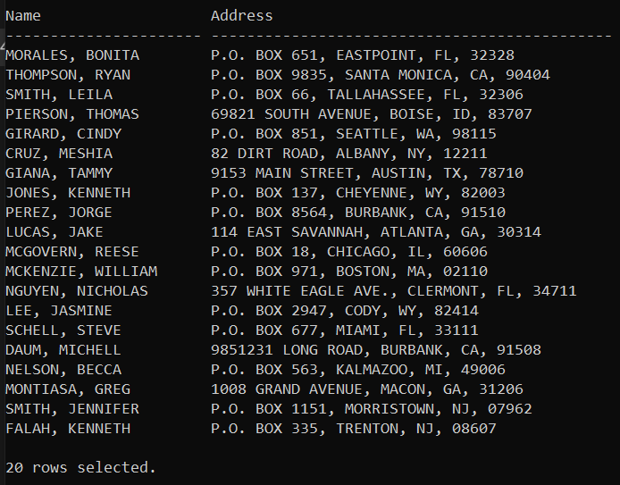

## Tips for Success

1. Use column aliases to create appropriate column headers.
2. Use **set linesize xxx,** in which xxx is a number to set the width of the output.

## Marking Criteria

You must pass all categories to pass the activity.

|  |  |  |  |
| --- | --- | --- | --- |
| **Categories** | **Fail** | **Pass** | **Score** |
| Submission provided | No | Yes | **Pass/Fail** |
| Attribution list provided | No | Yes | **Pass/Fail** |
| Reasonable attempt to solve each question | No | Yes | **Pass/Fail** |
| Spool file with commands included | No | Yes | **Pass/Fail** |
| **Pass/Fail** | | | |